Accredited Employer Work Visa – Accreditation Application
In September 2019, then Minister of Immigration, the Hon Iain Lees-Galloway, announced a change to immigration. A new work visa would be introduced that would replace six already existing visas. It would be a new process, one employer led. After several delays, that new work visa is being introduced, the Accredited Employer Work Visa (AEWV).
This new scheme will be of importance to every employer in New Zealand who is looking to employ migrant staff. With most migrant staff holding one of the six visa types that are being replaced, any future visa will require the employer to be accredited. Without accreditation, an employer will not be able to hire migrant staff under the new AEWV, which will likely mean the employer will not be able to hire migrant staff at all.
Therefore, it is extremely important that employers become accredited so that, should they need to hire new migrant staff, or allow current staff to apply for a new work visa, they are able to do so.

The purposes for the change
What should be clear from the beginning is that, despite using the same term, this is NOT the same as the previous accreditation process. That was aimed at just a small number of employers who could show a persistent shortage in their area.
Instead, the AEWV is about an employer led process, where the employer is the main contact with Immigration New Zealand. It is the employer that justifies that they should be permitted to employ migrants. It is the employer who shows that there are no citizens or residents available for the role. It is only then that the migrant can apply for the work visa.
The purposes given for the new visa are varied, but mostly focus around three factors; encouraging employment of New Zealanders with less reliance on migrants, reducing migrant exploitation, and increasing the median wage to move New Zealand from being a low wage economy. How it may accomplish these will be covered as we go through the process.
It is a three-stage process, which we will cover in more detail below. The stages are:
- Employers obtain accreditation.
- The employers show that the role cannot be filled by NZ citizens or residents.
- The employer invites the migrant to apply for the role.
The AEWV itself will be the primary work visa for most migrants in New Zealand. It replaces three of the more common work visas, as well as three others that were less common and were already being phased out. These are:
- Essential Skills Work Visa
- Essential Skills Work Visa – Approval in Principle
- Talent (Accredited Employer) Work Visa
- Long Term Skills Shortage List Work Visa
- Silver Fern Job Search Visa (which was closed soon after the AEWV was originally announced)
- Silver Ferm Practical Experience Visa

The Stages

Accreditation
The basics
Accreditation was previously limited to just a small number of companies, typically just over 1,000. These companies would need to go through a laborious process to prove that they were an employer who was looking to hire and train New Zealanders, and would only rely on migrant staff when required. Evidence would need to be provided to show the training and processes in place to back up their compliance with that obligation.
Under the AEWV scheme, any employer who wishes to employ migrant workers must be accredited. This then increases the number of companies needing to be accredited to several magnitudes greater. Due to this, a simpler process has been put in place for accreditation. This replaces the need to provide evidence of training programs with obligations to provide certain information to migrants. That information is focused on their rights.
Your initial accreditation will last 12 months, at which point it must be renewed. On renewal it will last for 24 months for most business, though with some exceptions we will detail below.
Differences in accreditation
There are four types of accreditation based on your business type and the number of migrants you would expect to have employed at any one time. The cost of accreditation varies dependent on the type of accreditation.
- Standard accreditation – This allows for up to five migrants at any one time to be employed. The cost of accreditation is $740.
- High-volume accreditation – This allows for any number of migrants to be employed. The cost of accreditation is $1220.
- Franchisee accreditation – This is for any company that operates under a franchise type model, and we can help you determine if you will fall under this requirement. Beyond the base requirements, franchisees must have been trading as a franchisee for at least 12 months or have 12 months experience in a similar business. If there is more than one employee, then at least 15% of staff must be citizens and residents guaranteed at least 30 hours per week. The cost of accreditation is $1980. Renewals for franchisee accreditation only last 12 months so must be renewed annually.
- Controlling third party accreditation – This is for staff placement roles, where staff are contracted out to do work for third parties. You must have a history of placing staff in New Zealand for the past 12 months and at least 15% of those staff must be New Zealand citizens or residents guaranteed at least 30 hours work per week. The cost of accreditation is $3870. Renewals for controlling third party accreditation only last 12 months so must be renewed annually.
Those looking to recruit migrants to plant, maintain, harvest or pack crops in the horticulture or viticulture industries should look at the Recognised Seasonal Employer scheme, as an AEWV will not be provided for people working in those roles.
If a company on standard accreditation needs to move to high-volume accreditation, there is an additional fee payable of $480 being the difference between the two original costs.
If your application for accreditation is declined, and you believe that a mistake was made in doing so, reconsideration of a declined application can be requested at a cost of $240.
For those companies that had accreditation through the old Talent (Accredited Employer) scheme, you may be exempt from paying for your accreditation if you held your previous accreditation on 23 May 2022, and your accreditation was due to expire on or after 23 November 2022. This will likely be a very small number of companies as application for the old scheme closed on 30 June 2021.
Necessary for accreditation
There are a number of requirements to gain accreditation. To start with, a New Zealand Business Number will be required, as will IRD registration.
As part of the application, you will need to agree to a number of obligations. We will provide you with documentation and guidance on meeting these obligations. These obligations are mostly based around providing a better work environment for employees, so they are aware of their rights, and less likely to experience exploitation. In agreeing with the obligations, you will likely need to make some small changes in the operation of your business, particularly your onboarding process. We will assist you with these changes. These include:
- An agreement that you will cover all recruitment costs, and not pass these on to the migrant. This includes not charging any fee or placing any obligation on the migrant that may be illegal, such as bonding agreements illegally binding the employee to the role.
- You must provide the employee with paid work hours to complete all of Employment New Zealand’s online employee modules on employment rights. This time must be given in the first month of employment, and you must keep records of the modules being completed as these may be requested by Immigration New Zealand. The current employment modules can be seen here https://employment.elearning.ac.nz/
- Your business staff who make employment decisions will need to complete online modules. These can also be found here https://employment.elearning.ac.nz/
- For those who have been in New Zealand for less than two years, in the first month of employment you must provide information about the local community and services including:
  - accommodation options
  - transport options, both private such as driver licencing information, and public transport options
  - cost of living estimates
  - how to access healthcare services
  - how to contact the Citizens Advice Bureau and what services they can provide
  - relevant community groups that may assist them with settling into New Zealand
- For all migrant employees, you must provide, in the first month of employment, details on:
  - how to obtain an IRD number
  - available options for industry training and qualifications
  - specific job and industry hazards
When needed, we can provide you with forms and documents that will assist you in monitoring and fulfilling these obligations. However, some obligations may be industry specific, so should be prepared by you or your staff.
Businesses need to be seen as being a viable, genuine business that can meet one of these financial requirements:
- Have not made a loss over the previous two years
- Have had a positive cash flow each month for the last six months
- Have enough capital or external investment for the business to remain viable
- Have a credible two-year plan to ensure the business remains viable
Companies or senior staff who have previously breached employment or immigration standards may be subject to a standdown period, and therefore be ineligible for accreditation for a period. We have, in the past, noted that Immigration New Zealand has placed further standdown periods in place due to its interpretation of its own instructions. This is something we have successfully challenged and can likely assist those in that situation.
Process for accreditation
Our process for accreditation has been setup to minimise this distraction for you.
We would ask you to complete the form at the end of this document. For most businesses, this will provide us with all of the necessary information to complete your accreditation application. For some clients, we may require further information and we will let you know what else we may need.
We will also need you to sign the attached INZ1279 form.
Immigration New Zealand estimates that accreditation will take ten working days for most applications to be processed.

Job Check
The purpose of the job check is to show that there is no citizens or residents available, and willing, to undertake the role. Its also a review of the conditions of the role, such as the pay, so that employers are not looking to pay a rate lower than citizens or residents would accept.
Previously, this evidence, called a labour market test, was provided by the employer to the migrant by way of the INZ1113 form. The migrant would then provide this with their application.
However, the new system, being employer lead, pushes this process on to the employer, and it is the employer who provides this information to Immigration New Zealand.
The exact process is not yet known, as the job check system opens on 20 June. However, there are some base details that are known. As part of the job check, a job description, employment agreement, copies of advertisements, and the results of those advertisements, must be provided to Immigration New Zealand. Typically, such advertising would be through a major online platform such as TradeMe or Seek, but some roles may have more specialised platforms to advertise on, or recruitment companies can be used.
Immigration New Zealand estimate that it will take them 10 working days to complete a job check application, although this cannot be shown yet as the system is not operating.
Once a job check has been confirmed, Immigration New Zealand will send you a job check token. This is valid for six months. It is a unique number that you provide to the migrant you wish to employ, and it will link that migrant’s application to your business and the related job check.
The Green List
Not all roles will require evidence of advertising. Similar to the old Long Term Skill Shortage List, Immigration New Zealand have created a list of roles where there is an established and acknowledged shortage. It has called this the Green List and it can be seen here https://www.immigration.govt.nz/opsmanual/#77204.htm.
Where a job check is conducted on a Green List role, and the business indicates it is a Green List role, Immigration New Zealand will not require evidence that there are no citizens or residents available, as that will be acknowledged. However, applicants who then apply must meet the requirement listed in the Green List. This will typically require a certain qualification or an acknowledgement by an industry body, and possibly some amount of experience. These are strict requirements in that they need to be perfectly met. Immigration New Zealand will not utilise discretion if something isn’t quite right.
The other exception is for those earning twice the median wage, so $55.52 per hour or the comparable annual salary. Such roles will not need to be advertised.

Visa application
The final step of the new process is the application itself. The migrant will submit the application, using the job check token. Their experience and qualifications must match those listed in the job check. They will also need to provide the other standard requirements such as medical checks, police certificates, valid passport etc.
If the application is declined, or the migrant does not complete the application, then you can request a replacement job token, as long as it is within the six-month period from the job check.
The visa application system is due to go live on 4 July 2022. Immigration New Zealand estimate that it will take 20 working days to process a visa application under this new system.

Who can be employed?
The new process creates a significant difference in who may be able to obtain a work visa, compared to the Essential Skills Work Visa process. With a view to creating a high wage economy, many migrants in low paid roles will be unable to be granted an AEWV. This will likely mean those jobs are filled by citizens or residents, or that the wages will be increased to meet the threshold. With a reduction on who can obtain Post Study Work Visas, and fewer partners of workers being able to work, which we will cover below, a large part of the workforce for such roles won’t be available.
The base requirement for those applying for an AEWV is that the role must be for at least 30 hours per week and must pay at least $27.76 per hour. Apart from the exceptions listed below, any role that does not pay $27.76 per hour, being the median wage calculated by Statistics NZ for the end of the June 2021 quarter, will not be eligible for a job check nor the granting of a visa.
There are some exceptions, but these will only be for a limited period of time. These are listed in more detail in Appendix 14 of the operational manual https://www.immigration.govt.nz/opsmanual/#77205.htm but we will briefly cover them here:
- Jobs in the construction and infrastructure sector, where the role is listed in Appendix 14, must be paid at $25 per hour or above.
- Jobs in the tourism and hospitality sector, where the role is listed in Appendix 14, must be paid at $25 per hour or above.
- Jobs in the Care Workforce sector, where the role is listed in Appendix 14, must be paid at $25.39 per hour or above.
This exception is time limited and is expected to be removed or updated in 12 months, at which point it will be likely that these roles will then need to match the then calculated median wage.
One thing to note is that, with the new AEWV, chefs will need to have at least a level 4 NZQA qualification for their role. They will no longer be able to get a work visa based on experience.

Partners
While not strictly related to the AEWV, this change will impact employers. Presently, those who hold an Essential Skills Work Visa and were being paid the median wage when they were granted the visa, can assist their partner in obtaining an open work visa. This is being changed in December 2022. From that point, only those who hold roles on the Green List will be entitled to assist their partner with an open work visa. All other partners will only be eligible for a visitor visa, meaning that the family will need to live off one income. We expect that this will make Green List roles in greater demand, but also provide upward pressure on the pay for other roles.

Conclusion
The new AEWV is a substantial change to the employment landscape in New Zealand. It is being put in place with good intentions, but it does create new challenges for employers, both in the handling of staff but also in staff retention.
If you would like us to assist you with your accreditation, and your operating under the AEWV scheme, please complete the form below, sign the INZ1279 at the end of this document, and return it to us. Our terms of engagement can be found here. If there are any questions you are unsure about, please leave it empty and we can work with you to complete it.

Business details
 | Item | Answer
 | Business name | Click or tap here to enter text.
 | Trading name | Click or tap here to enter text.
 | New Zealand Business Number | Click or tap here to enter text.
 | Address (head office) | Click or tap here to enter text.
 | Industry business operates in | Click or tap here to enter text.
 | IRD Number for business | Click or tap here to enter text.
 | Business website | Click or tap here to enter text.
 | Is your business currently on, or previously been on, Immigration New Zealand’s list of employers who may not hire migrants? | Click or tap here to enter text.
 | Has your business ever been convicted or charged for an offence under the Crimes Act 1961 for dealing in slaves, trafficking in persons, or smuggling migrants? | Click or tap here to enter text.
 | Has your business ever provided false or misleading information to Immigration New Zealand, or withheld material information? | Click or tap here to enter text.
 | Are you aware of any ongoing investigations or cases pending for any breach that, if proven, might require any of the above answers to be changed to yes? | Click or tap here to enter text.
 | In the last seven years, was your business re-established as a new legal entity which was substantially similar to a previous organisation? | Click or tap here to enter text.

Key people
Key people are typically the owners and/or senior management who can influence an organisation’s compliance with employment and immigration law.
If there is more than one key person, it may be easier to provide these details on a separate document or email.
 | Name | Click or tap here to enter text.
 | Date of birth | Click or tap to enter a date.
 | Country of birth | Click or tap here to enter text.
 | Country of citizenship | Click or tap here to enter text.
 | Passport number | Click or tap here to enter text.
 | Role in organisation | Click or tap here to enter text.
 | Gender | Click or tap here to enter text.
 | Is at least one director/partner of your business resident in New Zealand? | Click or tap here to enter text.
 | Are any of your key people bankrupt or subject to a No Asset Procedure? | Click or tap here to enter text.
 | Are any of your key people currently on the employer stand-down list issued by the Labour Inspectorate? | Click or tap here to enter text.
 | Are any of your key people currently banned from being a director or promoter of a business, or from being involved in the management of a business, in New Zealand? | Click or tap here to enter text.
 | Are any of your key people currently banned from being a director or promoter of a business, or from being involved in the management of a business, in any other country? | Click or tap here to enter text.
 | In the past five years, have any of your key people been convicted or charged for an offence in connection with any company, or for dishonesty, in New Zealand or any country overseas? | Click or tap here to enter text.
 | In the past seven years, has your business employed a person who was not entitled, under the Immigration Act 2009, to work in that role? | Click or tap here to enter text.
 | Have any of your key persons ever been convicted or charged for an offence under the Crimes Act 1961 for dealing in slaves, trafficking in persons, or smuggling migrants? | Click or tap here to enter text.
 | Has any of your key people ever provided false or misleading information to Immigration New Zealand, or withheld material information? | Click or tap here to enter text.
 | Are any of the key people aware of any ongoing investigations or cases pending for any breach that, if proven, might require any of the above answers to be changed to yes? | Click or tap here to enter text.
 | Are you aware of any key people who are currently or have previously been involved in any other organisation that has not been compliant with immigration standards? | Click or tap here to enter text.

Type of accreditation sought
These questions look at the type of accreditation sought. We can discuss this with you, particularly if you may be caught as a franchisee or you are providing staff to other businesses.
 | Has your business been operating or trading for more than 12 months? | Click or tap here to enter text.
 | Will your business be placing staff to work for other companies on a contractual basis (so a labour hire situation)? | Click or tap here to enter text.
 | Are you a franchisee? | Click or tap here to enter text.
 | How many migrant staff would you expect to employ at any one time in the next 12 months? | Click or tap here to enter text.

Viability of ongoing employment
These questions look at whether your business can provide employment that is sustainable. We may ask you for further details if there are any answers that we believe will cause Immigration New Zealand any concern
 | In every month of the last six months, has your organisation had positive cash flow? | Click or tap here to enter text.
 | Does your organisation have sufficient capital and/or external investment and/or cashflow to cover staff wages, operating costs, and any other costs of business such as inventory, over the next 12 months? | Click or tap here to enter text.
 | If you have answered no to both of the above, do your business have a viable two-year plan to reach such a situation? | Click or tap here to enter text.

Obligations
These are the obligations that you will need to meet with any employee hired under the AEWV. We can assist you with putting these obligations in to place.
 | Will your organisation ensure that people who make recruitment decision complete the online employer modules while the accreditation is current? | Click or tap here to enter text.
 | Does your business agree to not pass on any recruitment costs or fees to AEWV holders? | Click or tap here to enter text.
 | Does your business agree to not charge fees to AEWV holders, either inside or outside New Zealand, which would be unlawful if charged within New Zealand? | Click or tap here to enter text.
 | Will your business provide all AEWV holders with information about settling into New Zealand within one month of their employment? | Click or tap here to enter text.
 | Will your business provide AEWV holders with paid work time to complete the online employee modules within one month of starting work? | Click or tap here to enter text.
 | Will your business provide AEWV holders with work-related settlement information, such as how to obtain an IRD number, by the time they commence employment? | Click or tap here to enter text.

Once we have received this document from you, we will be able to assess your accreditation, request any further information we may require from you, and then submit your application for accreditation application. We will then work with you to prepare for the obligations of employing AEWV holders under the new regime.
Please let us know if you have any questions. We look forward to assisting you with this new process.
Yours faithfully
STACE HAMMOND
A M HUNT
Partner
ddi: +64 9 886 1499
mobile: +64 21 358 210
email: arranh@shlaw.co.nz

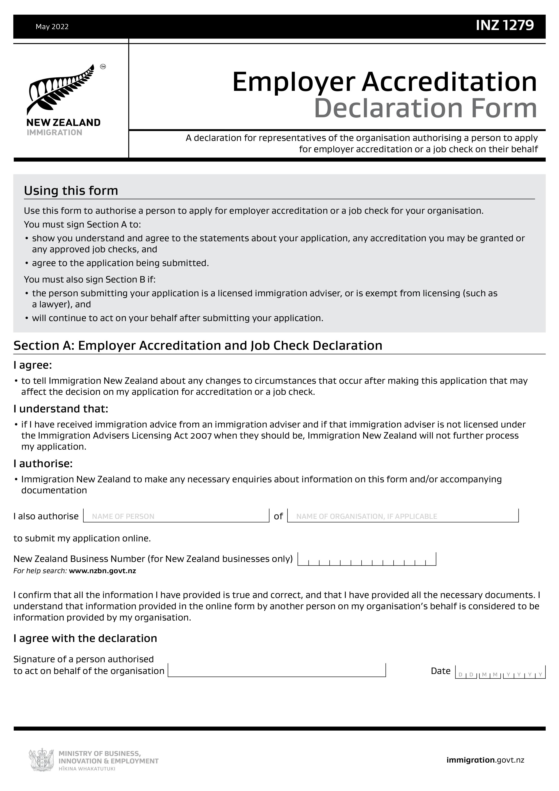
Stace Hammond
Arran Hunt
